
CSA15
Cloud Computing and Big Data Analytics
Guided Practical Workbook: Hadoop and MapReduce on Windows using WSL
Faculty | Dr C. Rajesh Babu
Employee ID | SSETSCS415
Department | Department of Computer Science and Engineering
Primary environment | Windows 10/11 with WSL2 Ubuntu
Practical focus | Install Hadoop, start HDFS/YARN, run MapReduce WordCount and record evidence
Why this Windows route is used
The students do not need a separate Linux virtual machine. Windows Subsystem for Linux provides a Linux command-line environment inside Windows, so Hadoop can be installed and tested with fewer platform compatibility issues than native Windows Hadoop.
Student Details
Student Name | J Bharath
Register Number | 192511234
Class / Section / Slot
Capstone Project Title | SkillForge - CO-Attainment  Cloud Tutor Using  Recommendation Analytics
GitHub Repository Link
Google Classroom Submission Date
Learning Outcome
After completing this practical, the student should be able to prepare a Windows-based Hadoop learning environment using WSL, verify Java and SSH, configure Hadoop in pseudo-distributed mode, use HDFS commands, run a MapReduce WordCount job, and connect the output to a capstone-style analytics problem.

Toolchain Required
Category | Tool | Purpose
Required | Windows 10/11 | Use a Windows laptop with administrator access for WSL installation.
Required | PowerShell / Windows Terminal | Used to install and manage WSL from Windows.
Required | WSL2 with Ubuntu | Runs Linux command-line tools directly on Windows without creating a separate Linux VM.
Required | Java JDK inside Ubuntu | Required by Hadoop.
Required | OpenSSH inside Ubuntu | Required for pseudo-distributed Hadoop services.
Required | Apache Hadoop | Used for HDFS, NameNode, DataNode, YARN and MapReduce.
Allied | VS Code with WSL extension | Optional, but helpful for editing config files from Windows.
Allied | PySpark / Google Colab | Used after Hadoop core to compare MapReduce and Spark analytics.
Allied | Power BI / Looker Studio / Tableau Public / Canva | Used for visualizing processed CSV output.
Native Windows Hadoop note
Installing Hadoop directly in Windows with winutils.exe is possible, but it is not selected as the main classroom path because version matching and permission errors can distract beginners from HDFS and MapReduce concepts.
Part A - Confirm Windows Readiness
Open Windows Search, type PowerShell, right-click Windows PowerShell, and choose Run as administrator. Keep the administrator PowerShell window open until WSL installation is complete.
winver
wsl --status
wsl --list --online
Checkpoint | Expected observation | Verified
Windows version checked | Windows 10/11 version information is visible.
WSL status checked | PowerShell displays WSL status or says WSL is not installed.
Online distributions listed | Ubuntu appears in the available distribution list.
Evidence Space: Paste Windows version and WSL status screenshot. (expand this space if required).
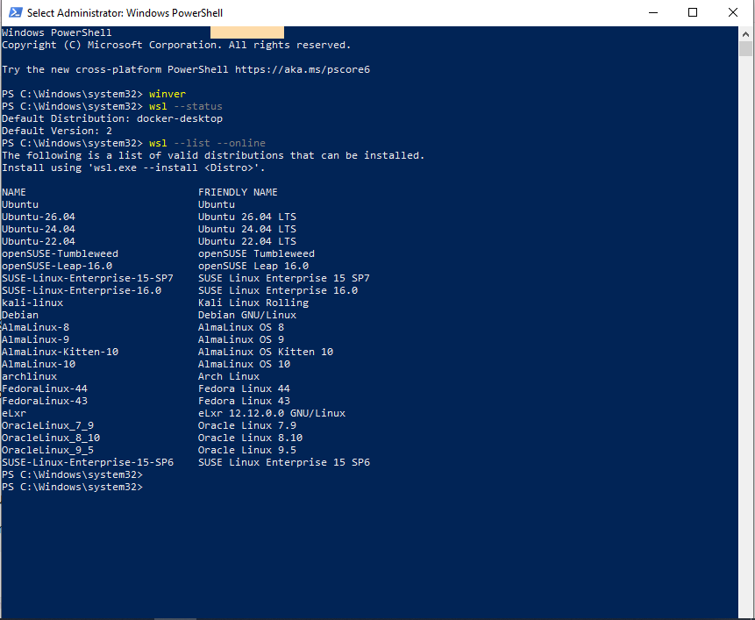
Part B - Install WSL2 Ubuntu
In administrator PowerShell, install Ubuntu through WSL. If the system asks for restart, restart Windows and open Ubuntu from the Start menu after restart.
wsl --install -d Ubuntu
# After restart, open Ubuntu from Start menu.
# Create a Linux username and password when Ubuntu asks.
wsl --set-default-version 2
wsl -l -v
Checkpoint while creating Ubuntu account
The password typed in Ubuntu may not show on screen. This is normal terminal behavior. Type the password carefully and press Enter.
Checkpoint | Expected observation | Verified
Ubuntu installed | Ubuntu opens from Start menu.
Linux user created | Ubuntu terminal shows a username prompt.
WSL version verified | wsl -l -v shows Ubuntu running as version 2.
Evidence Space: Paste WSL distribution/version screenshot. (expand this space if required).

Part C - Update Ubuntu and Install Java/SSH
All commands from this point must be typed inside the Ubuntu terminal, not in Windows PowerShell.
sudo apt update
sudo apt upgrade -y
sudo apt install -y openjdk-11-jdk openssh-server rsync wget tar nano
java -version
sudo service ssh start
ssh localhost
exit
When SSH asks whether to continue connecting, type yes. If Ubuntu asks for password, enter the Linux user password.
Checkpoint | Expected observation | Verified
Ubuntu packages updated | apt update and upgrade finish without fatal error.
Java verified | java -version displays OpenJDK.
SSH tested | ssh localhost opens a shell and exit returns to the prompt.
Evidence Space: Paste Java and SSH verification screenshots. (expand this space if required).
Part D - Create Hadoop User and Passwordless SSH
Create a dedicated Hadoop user. This helps separate Hadoop files from the normal Ubuntu account.
sudo adduser hduser
sudo usermod -aG sudo hduser
su - hduser
ssh-keygen -t rsa -P '' -f ~/.ssh/id_rsa
cat ~/.ssh/id_rsa.pub >> ~/.ssh/authorized_keys
chmod 0600 ~/.ssh/authorized_keys
ssh localhost
exit
Checkpoint | Expected observation | Verified
hduser created | Prompt changes after su - hduser.
SSH key generated | id_rsa and authorized_keys are created.
Passwordless SSH works | ssh localhost logs in without asking hduser password.
Evidence Space: Paste hduser and passwordless SSH evidence. (expand this space if required).
Part E - Download and Install Hadoop
Use an official Apache Hadoop binary release. If the exact version is unavailable later, open the Apache downloads page and select the latest stable Hadoop 3.x binary tar.gz file.
cd ~
wget https://downloads.apache.org/hadoop/common/hadoop-3.4.2/hadoop-3.4.2.tar.gz
tar -xzf hadoop-3.4.2.tar.gz
sudo mv hadoop-3.4.2 /usr/local/hadoop
sudo chown -R hduser:hduser /usr/local/hadoop
/usr/local/hadoop/bin/hadoop version
Evidence Space: Paste Hadoop version output. (expand this space if required).
Part F - Set Hadoop Environment Variables
Open the shell configuration file for hduser and add Hadoop paths.
nano ~/.bashrc
# Add at the end:
export JAVA_HOME=/usr/lib/jvm/java-11-openjdk-amd64
export HADOOP_HOME=/usr/local/hadoop
export HADOOP_INSTALL=$HADOOP_HOME
export HADOOP_MAPRED_HOME=$HADOOP_HOME
export HADOOP_COMMON_HOME=$HADOOP_HOME
export HADOOP_HDFS_HOME=$HADOOP_HOME
export YARN_HOME=$HADOOP_HOME
export HADOOP_COMMON_LIB_NATIVE_DIR=$HADOOP_HOME/lib/native
export PATH=$PATH:$HADOOP_HOME/sbin:$HADOOP_HOME/bin
source ~/.bashrc
hadoop version
Evidence Space: Paste environment variable section and hadoop version output. (expand this space if required).
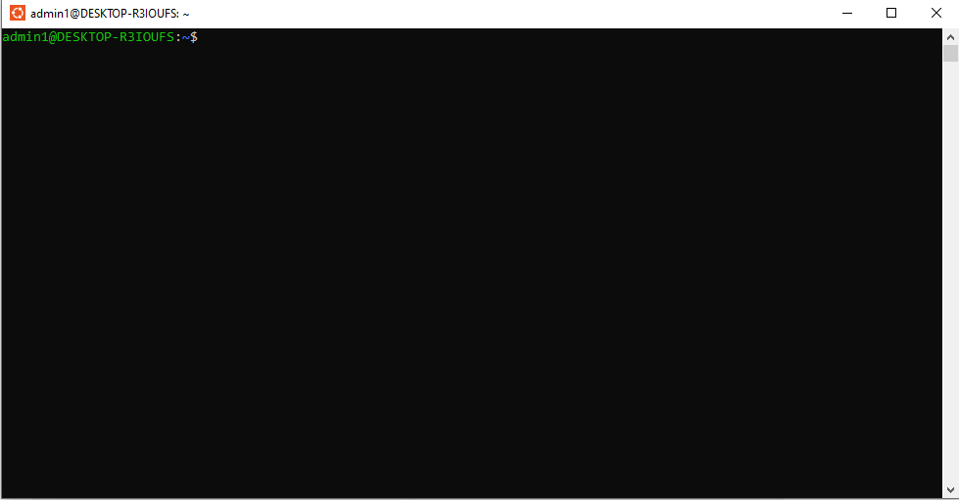
Part G - Configure Hadoop XML Files
Edit the Hadoop configuration files. These settings make Hadoop run as a single-node pseudo-distributed cluster in WSL Ubuntu.
cd /usr/local/hadoop/etc/hadoop
nano hadoop-env.sh
# Set or replace:
export JAVA_HOME=/usr/lib/jvm/java-11-openjdk-amd64
nano core-site.xml
<configuration>
<property>
<name>fs.defaultFS</name>
<value>hdfs://localhost:9000</value>
</property>
</configuration>
mkdir -p /usr/local/hadoop/hadoop_data/hdfs/namenode
mkdir -p /usr/local/hadoop/hadoop_data/hdfs/datanode
nano hdfs-site.xml
<configuration>
<property><name>dfs.replication</name><value>1</value></property>
<property><name>dfs.namenode.name.dir</name><value>file:/usr/local/hadoop/hadoop_data/hdfs/namenode</value></property>
<property><name>dfs.datanode.data.dir</name><value>file:/usr/local/hadoop/hadoop_data/hdfs/datanode</value></property>
</configuration>
cp mapred-site.xml.template mapred-site.xml 2>/dev/null || true
nano mapred-site.xml
<configuration>
<property><name>mapreduce.framework.name</name><value>yarn</value></property>
</configuration>
nano yarn-site.xml
<configuration>
<property><name>yarn.nodemanager.aux-services</name><value>mapreduce_shuffle</value></property>
</configuration>
Evidence Space: Paste screenshots of the edited XML files. (expand this space if required).
Part H - Format NameNode and Start Hadoop
Format NameNode only during the first setup. Then start HDFS and YARN services.
hdfs namenode -format
start-dfs.sh
start-yarn.sh
jps
Expected jps result
Look for NameNode, DataNode, SecondaryNameNode, ResourceManager and NodeManager. If one is missing, use the troubleshooting section.
Checkpoint | Expected observation | Verified
NameNode available | jps shows NameNode.
DataNode available | jps shows DataNode.
YARN available | jps shows ResourceManager and NodeManager.
HDFS UI opens | Windows browser opens http://localhost:9870.
YARN UI opens | Windows browser opens http://localhost:8088.
Evidence Space: Paste jps output, HDFS UI and YARN UI screenshots. (expand this space if required).
Guided Project 1 - Word Frequency Analytics using Hadoop MapReduce
Scenario
A cloud product generates activity logs. The product owner wants to know which actions occur most frequently. You will upload a small log file into HDFS and run MapReduce WordCount.
Perform
mkdir -p ~/hadoop_wordcount/input
cat > ~/hadoop_wordcount/input/app_log.txt <<'EOF'
login search booking payment logout
login search search booking complaint
payment booking notification search
login login booking analytics report
EOF
hdfs dfs -mkdir -p /user/hduser/wordcount/input
hdfs dfs -put -f ~/hadoop_wordcount/input/app_log.txt /user/hduser/wordcount/input/
hdfs dfs -ls /user/hduser/wordcount/input
hdfs dfs -cat /user/hduser/wordcount/input/app_log.txt
hdfs dfs -rm -r -f /user/hduser/wordcount/output
hadoop jar /usr/local/hadoop/share/hadoop/mapreduce/hadoop-mapreduce-examples-*.jar wordcount /user/hduser/wordcount/input /user/hduser/wordcount/output
hdfs dfs -ls /user/hduser/wordcount/output
hdfs dfs -cat /user/hduser/wordcount/output/part-r-00000
Observe and Record
Checkpoint | Expected observation | Verified
Input uploaded | HDFS lists app_log.txt. | Yes
MapReduce completed | Terminal shows successful job completion. | Yes
Output created | part-r-00000 appears. | Yes
Counts interpreted | Student identifies frequent words/actions. | Yes
Paste terminal output showing HDFS upload and WordCount result. (expand this space if required).
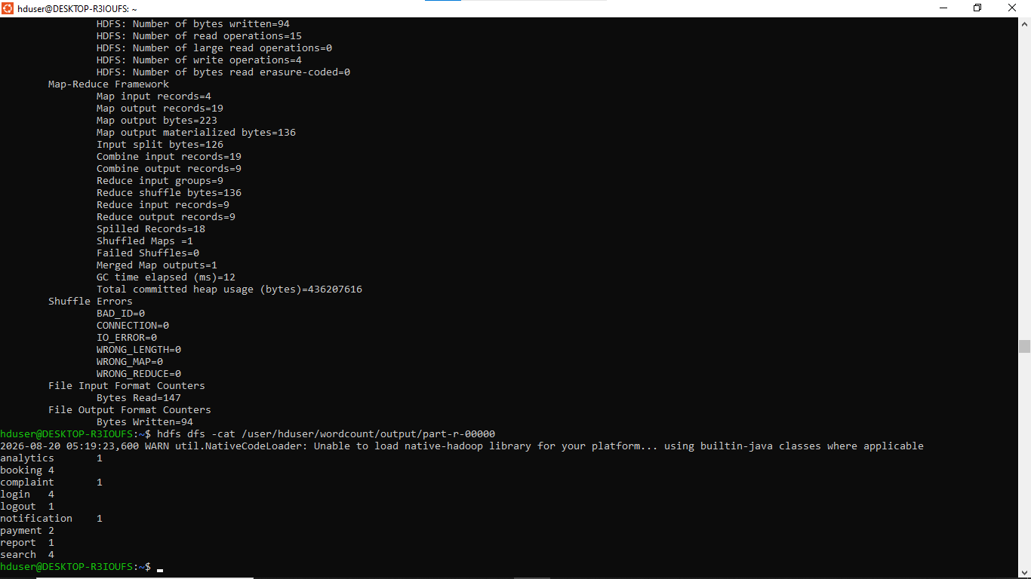
Terminal output: app_log.txt uploaded to HDFS and WordCount job run, showing part-r-00000 with word frequency counts.
Explain what Map produced, what Reduce produced, and how this relates to your capstone product. (expand this space if required).
The Map phase read each line of app_log.txt and, for every action token (login, search, booking, payment, logout, complaint, notification, analytics, report), emitted an intermediate key-value pair of the form (word, 1). With 4 input lines containing 19 tokens in total, the Map input records counter showed 4 and the Map output records counter showed 19, one emitted pair per token.
The Reduce phase grouped all pairs that shared the same key and summed their values, producing one final (word, total count) record per distinct action - 9 unique actions, so Reduce output records = 9. The output file part-r-00000 confirmed this: booking=4, login=4, search=4, payment=2, and analytics, complaint, logout, notification, report=1 each.
This mirrors the capstone product directly: the raw activity log is analogous to the application's clickstream/event log, and the WordCount pattern is the same aggregation technique needed to answer "which user actions happen most often" - a core analytics question for the capstone's usage-monitoring or engagement-analytics feature.
Extend
Add five more lines connected to your capstone project, rerun WordCount, and compare the new output with the earlier output.
nano ~/hadoop_wordcount/input/app_log.txt
hdfs dfs -put -f ~/hadoop_wordcount/input/app_log.txt /user/hduser/wordcount/input/
hdfs dfs -rm -r -f /user/hduser/wordcount/output2
hadoop jar /usr/local/hadoop/share/hadoop/mapreduce/hadoop-mapreduce-examples-*.jar wordcount /user/hduser/wordcount/input /user/hduser/wordcount/output2
hdfs dfs -cat /user/hduser/wordcount/output2/part-r-00000
Paste capstone-linked WordCount output and write the insight obtained. (expand this space if required).
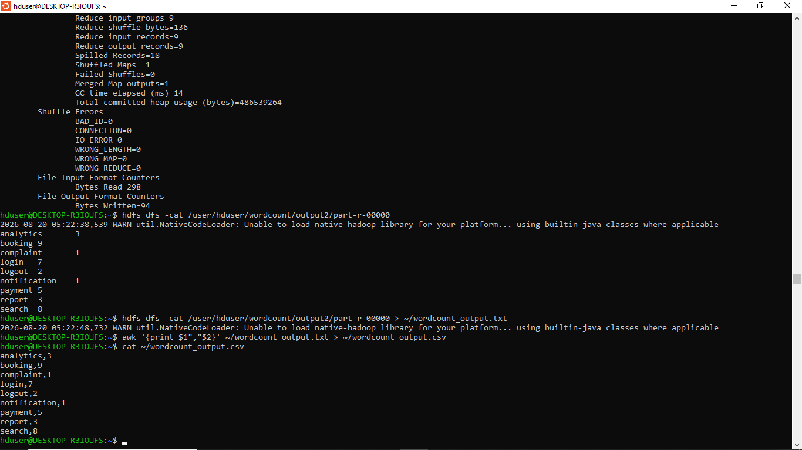
Extended dataset output2/part-r-00000, plus export of the result to wordcount_output.txt and wordcount_output.csv using awk.
Insight: After adding five capstone-linked lines and rerunning WordCount, every count increased, and the relative ranking of actions changed. In the first run booking, login and search were tied at 4 each; in the extended run booking pulled clearly ahead at 9, followed by search at 8 and login at 7, while payment (5) and report (3) grew noticeably faster than logout and notification, which stayed low (2 and 1). This shows that a small amount of additional activity data can shift which action looks "most frequent," so for the capstone product, dashboards built on a short log sample should be refreshed regularly rather than trusted as a one-time snapshot - booking and search-related actions are the ones most worth optimizing based on this trend.
Allied Big Data Tools After Hadoop Core
PySpark in Google Colab
Use this when Spark practice is needed without installing Spark locally.
!pip install pyspark -q
from pyspark.sql import SparkSession
from pyspark.sql.functions import explode, split, col
spark = SparkSession.builder.appName('CSA15BigData').getOrCreate()
data = [('login search booking',), ('payment booking search',), ('login analytics report',)]
df = spark.createDataFrame(data, ['line'])
words = df.select(explode(split(col('line'), ' ')).alias('word'))
words.groupBy('word').count().orderBy('count', ascending=False).show()
Paste PySpark output and write one difference between Hadoop MapReduce and Spark. (expand this space if required).
Dashboard Visualization
Export the Hadoop output and visualize it using Power BI, Looker Studio, Tableau Public or Canva Charts.
hdfs dfs -cat /user/hduser/wordcount/output2/part-r-00000 > ~/wordcount_output.txt
awk '{print $1","$2}' ~/wordcount_output.txt > ~/wordcount_output.csv
Paste dashboard screenshot and mention the chart used. (expand this space if required).
Troubleshooting
Issue | Possible reason | Correction
wsl command not found | WSL is not installed or Windows is not updated. | Use Windows Update and follow manual WSL installation.
Ubuntu does not open | Installation incomplete or restart pending. | Restart Windows and open Ubuntu again.
sudo apt update fails | Network or proxy issue. | Check internet and retry later.
ssh localhost refused | SSH service not started. | Run sudo service ssh start.
jps does not show daemons | Hadoop services did not start correctly. | Check XML files and run start-dfs.sh/start-yarn.sh again.
Output folder already exists | Hadoop will not overwrite output. | Delete output path before rerun.
Submission Checklist
Checkpoint | Expected observation | Verified
WSL evidence | Windows WSL version screenshot.
Ubuntu evidence | Ubuntu terminal screenshot.
Java/SSH evidence | Java version and SSH localhost verified.
Hadoop evidence | Hadoop version and XML configuration evidence.
Daemon evidence | jps output and web UI screenshots.
MapReduce evidence | WordCount input/output evidence. | Yes
Capstone extension | Capstone-linked modified dataset and output. | Yes
Allied tool evidence | PySpark or dashboard evidence, if completed.
GitHub repository | Workbook and screenshots uploaded.
Google Classroom | Final file submitted in GCR.
Assessment Rubric
Criterion | Expected quality | Marks
Windows/WSL setup | WSL Ubuntu is installed and verified. | 15
Dependency setup | Java, SSH and Hadoop are installed with evidence. | 20
Hadoop configuration | HDFS/YARN XML files are configured correctly. | 20
MapReduce execution | WordCount runs and output is interpreted. | 20
Capstone connection | Student extends the dataset using capstone context. | 15
Submission quality | GitHub/GCR evidence is complete and readable. | 10
Official References
Reference | Official link
Microsoft WSL Documentation | https://learn.microsoft.com/en-us/windows/wsl/
Install WSL | https://learn.microsoft.com/en-us/windows/wsl/install
Manual WSL Installation | https://learn.microsoft.com/en-us/windows/wsl/install-manual
Apache Hadoop Single Node Cluster | https://hadoop.apache.org/docs/stable/hadoop-project-dist/hadoop-common/SingleCluster.html
Apache Hadoop MapReduce Tutorial | https://hadoop.apache.org/docs/stable/hadoop-mapreduce-client/hadoop-mapreduce-client-core/MapReduceTutorial.html
Apache Spark Documentation | https://spark.apache.org/docs/latest/
PySpark Installation | https://spark.apache.org/docs/latest/api/python/getting_started/install.html

